Use External source data – Manual
STEP 1 – Create files for external source:
In SPSS production system for XMPI it is possible to use external source data. The user should add external source data (ex: “…/TradeIndexMozambique/data/Export - 2023_External_source_Q1”) on same format as customs data for each quarter (comma separated file – CSV UTF-8 (comma separated)):
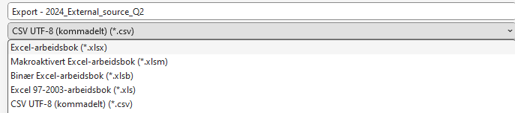
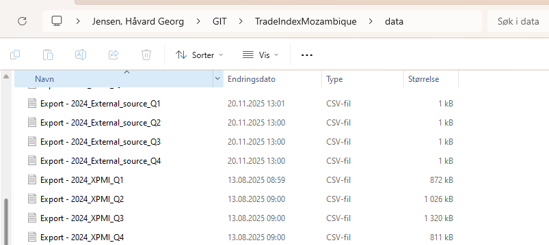

Customs data structure:
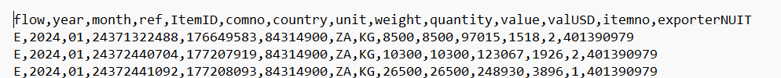
External source data structure:
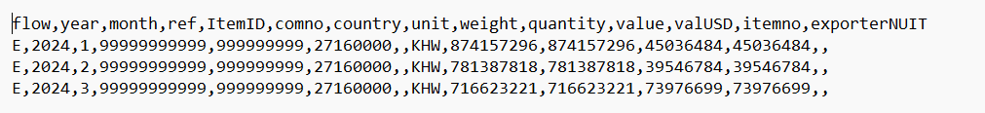
It is the same structure, but it is not necessary to put data into all variables. The mandatory variables are flow, year, month, ref, comno, unit, weight, quantity and value. Keep other variables blank. Use ref ‘99999999999’
STEP 2 – Update catalogue for wich commodities that use external source:
- Update “…/TradeIndexMozambique/cat/Use_external_source”
Add HS8 – code for commodity that use external source:
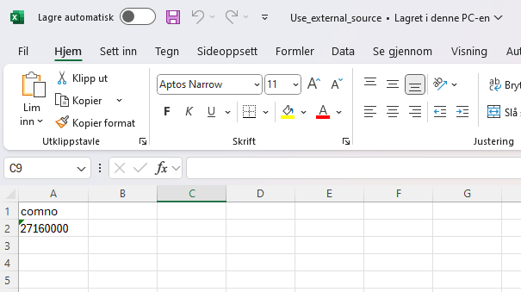

There are to pages, one for each flow:


Commodities in this catalogue will:
- Customs data will be deleted
- External source data will be added

STEP 3 – Run syntax:
When the external source data is added to the data folder you can run the SPSS syntax. The program will remove all rows for commodities in the “…/cat/Use_external_source” in the customs data and afterwards add the data from …/data/Export - year_External_source_Quarter”.

The external source data is not checked for outliers or removed in the sample selection process This exception is present in following syntax:
T10M Read_trade_quarter:
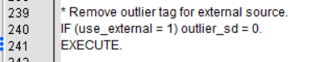
A20M CreateWeightBase:
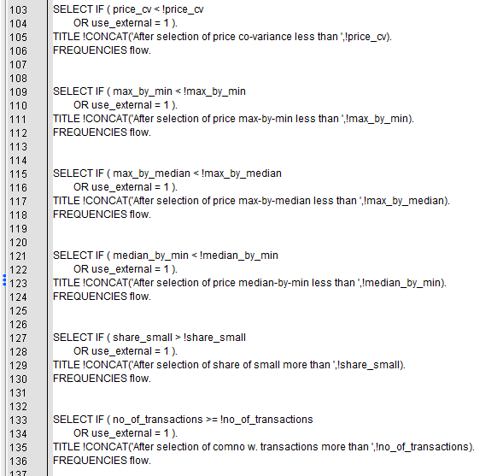
A30M Base_price:
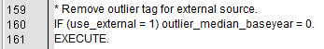
T40M Price_control:


STEP 4 – Check output:
Make sure that the commodities and data from external source is added:
When running the read_trade_quarter you get an output for commodities with external source data (the commodity is tagged with an x):
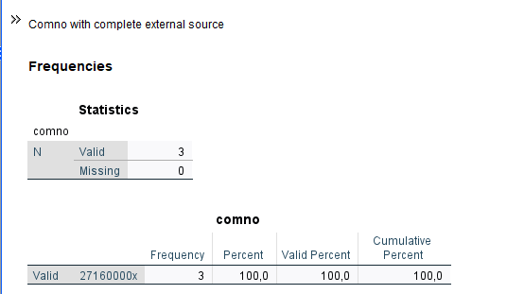
If there are no data added, you get a warning:

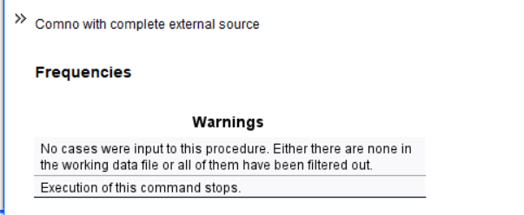

STEP 5 – Update list for special series:
If the commodity with external source should be included in a special series, you must update the catalogue with commoditiynumber+’x’:

STEP 6 – Consider using external source data for those with “incomplete external source data” in the customs dataset:
Consider using complete external source for those commodities with external source data in the customs dataset. Ideally you should have no records here, either by adding complete external source data, or removing external source data from customs data:
